CCBUG Tuggerah - Budgewoi FAST ride
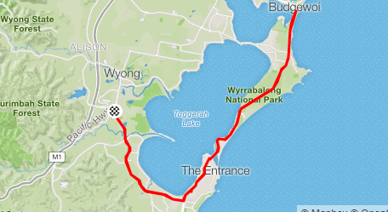

A fast paced (28kph+) bunch ride, starting from Tuggerah Train Station (macdonalds side) at 07:00am, please arrive at 06:50 am for a pre ride brief.
Ride Distance: 60 kms Altitude Gain: 459 m
Ride Surface: Road Average Speed : 28+kph
Ideal for: Road Est. Duration: 2 hrs
Child Suitable : NO
Grade: Hard
Ride Leader: Wayne 0423 967 343
The route is all main road riding and you must be confident with traffic and in a tight bunch at an average speed of over 28kph. We have a “no drop” policy however on this particular ride, you are expected to do above 28-30kph average over the entire ride. There are approximately 5 inclines each way throughout this ride.
The route starts at Tuggerah Train station, heads east along Wyong Road to Shelley Beach Roundabout, then north through The Entrance, continuing North along Wilfred Barrett Drive to Budgewoi roundabout, and return.
This is a training ride so there will be no coffee stops or breaks (excluding mechanical failures) during this ride, however we will enjoy a well-earned coffee at Tuggerah Macdonalds on completion of the ride.
Opt In Points:
Tuggerah Station (macdonalds side)
Roundabout on Cnr Wyong Road & Shelley Beach Road
Opt Out Points:
The Entrance Bridge.
Noraville roundabout
If you intend leaving the ride early please notify the ride leader before leaving.

Cue Sheet
Proceed onto Pacific Highway 0.0
Left onto Wyong Road 0.2
Left onto The Entrance Road at roundabout (left turn lane, not roundabout) 11.9
Left at roundabout adjacent to 7/11 14.5
Right onto Coral Street 15.8
Left at roundabout onto A49 16.0
Continue across bridge, onto Wilfred Barrett Drive 16.0
Continue through Noraville roundabout 26.7
U turn around Budgewoi roundabout Proceed onto Central Coast Highway 30.1
Continue through roundabout on Central Coast Highway 33.5
Continue on The Entrance Bridge 43.5
Right at roundabout onto A49 44.2
Left onto Oakland Avenue 44.4
Right at roundabout onto A49 45.6
Right at roundabout onto Wyong Road 48.3
Right onto Pacific Highway at Tuggerah 60.6
Arrive at Finish 60.7

