Woy Woy to Gosford Boomerang Ride
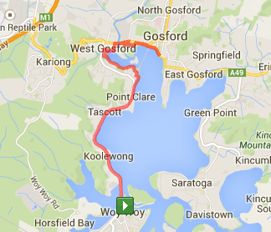
Ride Distance: | 25 kms | Altitude Gain: | 120 m
Grade*: | Easy | Average Pace*: | Slow
Ride Surface: | Shared Path | Est. Duration: | 2 hrs
Ideal for: | Any type of bicycle | Child Suitable*: | 10+

Ride Summary:
The is a slow paced ride along the beautiful Coastal Cycleway (or Point to Pelicans cycleway/shared path), with great views of Brisbane Waters. We ride over Spike Milligan bridge and through several parks along the way.
This ride starts at the Fishermans Wharf (just a few minutes ride from Woy Woy train station) and ends back in Woy Woy.
The ride may also be run in reverse (Gosford to Woy Woy Boomerang), starting on the shared path near Gosford Pool.
Coffee stop normally at the half way point or upon completion.
Opt-out possible at Gosford waterfront (about 1km to Gosford station) for a shorter ride.

