CCBUG Cruise & Coffee
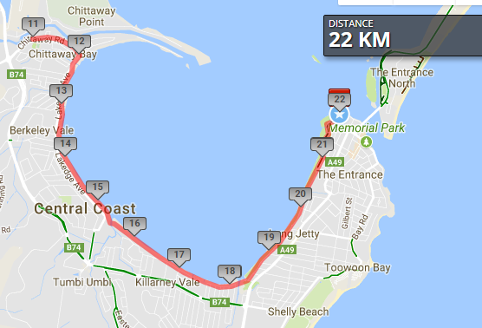

Ride Distance: | 22 kms | Altitude Gain: | 75m
Grade: | Easy | Average Pace¹: | 15-17
Ride Surface: | Path | Est. Duration: | 2 hrs
Ideal for: | Any bike | Child Suitable¹: | 7+
RidesAssist: | Yes

Ride Summary:
An easy cruise along the Tuggerah Lake shared path from The Entrance to Chittaway, or from Chittaway to The Entrance, with a short section of quiet road around Chittaway. Enjoy the lake views and meeting “long jetty” in person, before stopping for coffee at The Entrance.
Ride Details –
A ride from Picnic Point Reserve The Entrance to Chittaway Bay Public School, or visa versa, along the shared path alongside Tuggerah Lake.

Opt in points
For The Entrance starts: Chittaway Public School
For Chittwaway starts: Picnic Point Reserve The Entrance

Opt out points

As per Opt in points

Water & Toilet Loctions

Picnic Point Reserve, The Entrance
Beside the long jetty jetty

Map Reference:

http://www.mapmyride.com/routes/view/1890342227

Ride Leaders Personal Notes:
Include any alternate routes/detours, or other points of interest

Cue Sheet – The Entrance To Chittaway

Distance From Start | Direction to turn | Street / Location | Hazards / notes
0 | South | Picnic Point Reserve shared path | Watch for cars in the carpark and at crossings
4 | Straight | Shared path | Bridge; watch for bollards
9.8 | Right | Lakedge Ave | Watch for bollards & cars
10 | Left | Chittaway Rd | Watch for cars
11 | Stop | Turn around | Chittaway Public School; watch for cars!
12 | Right | Lakedge Ave | Watch for cars
12.2 | Left | Shared path | Watch for bollards
11.6 | Stop | Long jetty jetty | Bikes off the path while you read about the long jetty; toilet stop
14 | Right | The Entrance Rd
15.2 | Right | Oakland Ave
15.3 | Left | Bent St
15.4 | Stop | Bent St

For more details on Grading, Avg Pace and Children on rides, checkout www.ccbug.org.au
Estimated duration includes normally planned stops such as for regroups and coffee, but excludes mechanicals.

