Terrigal loop of pain
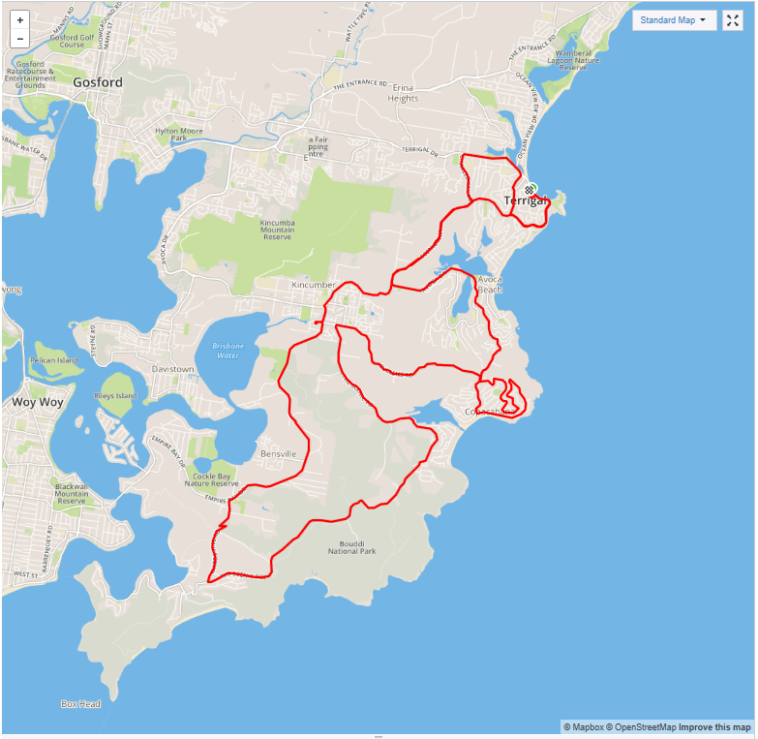

Ride Distance: | 50kms | Altitude Gain: | 1,077m
Grade: | Hard | Average Pace¹: | 23-25 km
Ride Surface: | Road | Est. Duration¹: | 2.0 – 2.5 hrs
Ideal for: | Road Bikes | Child Suitable1: | n/a
RidesAssist: | Experienced (Booking required)

Ride Summary:
A Medium to Hard grade ride leaving from the popular ritzy beachside area of Terrigal, passing through Avoca, Copacabana then up to Killcare via Scenic Road, down Wards hill and back to Terrigal via Scenic Highway. The ride starts and ends at the Terrigal Surf Club carpark. This ride is perfect for those wanting to strengthen their hill climbing or training for an event.

All on roads and road shoulders, with some busy traffic roads, so you need to be comfortable cycling on the road with some passing traffic. Ride pace will be slower climbing, so short regroups are arranged for the top of each climb.

Coffee will be at the Terrigal Surf Café upon completion. We will skip Wards hill if wet.
For more information on this ride including when it is next scheduled, please refer to the CCBUG Rides Calendar at www.ccbug.org.au or checkout our events on Facebook www.facebook.com/CentralCoastBicycleUserGroup
Ride Details –
You need to be comfortable cycling on the road/road shoulder with some fast passing traffic. The pace will be fast (30km/h + on the flat) however in sections the ride pace will reduce for conditions such as climbing hills.

This ride is suitable for road bikes only.

There are a couple of sections of the ride which require cyclists to ride as a group, take over a road lane to more safely turn right, therefore you need to be comfortable to stay with the pack and to look over your right shoulder to make sure the road is clear behind you before moving out on to the road for the turn.

If we find wet roads we will skip Wards Hill and return via The Scenic Rd to Kincumber.

Opt in points

The ride will start at Terrigal Surf Club carpark. There are no other opt in points for this ride.

Opt out points

There are no train stations on the route, however there are bus stops along the way which would take you to Gosford (if the bus driver lets you on with your bike).
You can turn around at any point and retrace the route, but please let the ride leader or sweep know BEFORE you leave the ride!

Water & Toilet Locations

Water can be filled at The Surf Café prior to starting the ride and at Marie Byles Lookout.

Toilets are located at Terrigal Surf Club and Maitland Bay Beach carpark. If you need to go, please let the ride leader know (discretely).

Map Reference:

https://www.mapmyride.com/routes/view/2183614249

Ride Leaders Personal Notes:

Cue Sheet –

Distance Marker | Distance in KM | Direction | Street / Location | Hazards / notes
0.0 |  | Start | Commence at Terrigal SLSC Carpark | Terrigal Drive, cnr Painters Lane
0.0 |  | Left | Scenic Highway | Ride through main street of Terrigal, Speed humps then hill climb, narrow shoulder
2000m | 2.0 | Stop | Scenic Highway | Regroup
0.0 | 2.0 | Right | Barnhill Road | Watch for cars when moving out onto road
300m | 2.3 | Straight | Barnhill Road | Single car filter chicane
200m | 2.5 | Left | Whiting Avenue | Steep downhill for 100m
400m | 2.9 | Left | Barnhill Road
100m | 3.0 | Stop | Terrigal Drive | Give way to traffic
100m | 3.1 | Straight | Terrigal Drive | Straight through roundabout
800m | 3.9 | Straight | Terrigal Drive | Straight through roundabout
500m | 4.4 | Left | Charles Kay Drive | Steep climb
1100m | 5.5 | Right | Scenic Highway | Turn right at roundabout
100m | 5.6 | Stop | Scenic Highway | Regroup
2600m | 8.2 | Left | Avoca Drive | Turn left at roundabout
2100m | 10.3 | Right | Cape Three Points Road | Right at roundabout, claim hill
1400m | 11.7 | Stop | Cape Three Points Road | Regroup at water tower
900m | 12.6 | Left | Chico Street | Steep decent
400m | 13.0 | Left | Del Mar drive | Steep decent
900m | 13.9 | Left | Del Rio Drive
100m | 14.0 | Left | Segura Street
300m | 14.3 | Left | Oceano Street | Climb hill
1200m | 15.5 | Right | Del Monte Place | Descend hill
1500m | 17.0 | Straight | Del Monte Place | Through roundabout
100m | 17.1 | Straight | Del Monte Place | Through roundabout
300m | 17.4 | Right | Pampas Avenue | Climb Hill
1000m | 18.4 | Left | Cullens Road | Good road surface, narrow shoulder
4000m | 22.4 | Left | The Scenic Road | Turn left at roundabout
100m | 22.5 | Straight | The Scenic Road | Slow pace, bunch up riders (sweep – all on)
4500m | 27.0 | Straight | The Scenic Road | Hill climb, rough surface, narrow
4800m | 31.8 | Stop | Marie Byles Lookout | Regroup and fill water from tape. There is bush for nature calls
1500m | 33.3 | Right | Wards Hill Road
1100m | 34.4 | Straight | Wards Hill Road | Steep decent 20% plus
300m | 34.7 | Straight | Wards Hill Road | Steep left hairpin 15kmph
100m | 34.8 | Straight | Wards Hill Road | Steep right hairpin 25kmph
700m | 35.5 | Stop | Empire Bay Drive | Regroup before intersection, give way to traffic
0.0m | 35.5 | Right | Empire Bay Drive | Main road, good shoulder, cycle lane
5700m | 41.2 | Straight | Empire Bay Drive | Straight through at roundabout
400m | 41.6 | Right | Avoca Drive | Take right lane, turn right at roundabout, watch for traffic
1900m | 43.5 | Straight | Scenic Highway | Straight through at roundabout
2800m | 46.3 | Straight | Scenic Highway | Straight through at roundabout
2800m | 49.1 | Left | Kurrawyba Avenue | Watch, pedestrian crossing
100m | 49.2 | Right | Church Street | Pedestrian crossing
100m | 49.3 | Right | Campbell Crescent | Pedestrian crossing
100m | 49.4 | Left | Terrigal Drive | Traffic, pedestrians
100m | 49.5 | Right | Terrigal Surf Club Carpark | Turn right into surf club carpark
YAY!! |  |  | End of ride – head for cafe

Refer to the www.ccbug.org.au for more information.

